

Ms. Roberts’ 5th Grade

Week of 10/9/17 – 10/12/17



HOMEWORK:

* If you desire to work in the classroom as a **volunteer**, or join us on upcoming field trips, you will need to fill out a background check form.
* Please return the **blue homework folders** on Monday. Hardly any of the students are bringing them back.
* **Study Spelling and vocabulary** words. Sheet Due Monday.
* **20 minutes of reading** every day in a reading log. Due at the end of the week in reading class.
* My **math** kids are bringing home math sheets to practice almost every day. They are to only work on them for 30 minutes at most.
* I am providing some snacks that the kids can purchase with PAT Pride bucks that they earn for good behavior. If you would like to donate snacks for their snack time in the morning, you are encouraged to do so. Gluten free snacks appreciated as well.

From Ms. Roberts:

We are midway through the first term of school!

It doesn’t seem possible, yet here we are, almost done with the 5th week of school! The students are being expected to take more personal responsibility. That is actually the attribute we are focusing on for Student of the Month in October. I am so pleased with how the students have been doing. They have been improving every day.

On a note of personal responsibility, I am expecting that the students be to class on time, using their frequent 5 minute transition periods to get their supplies for their next class, use the restroom, and get drinks. I have water coolers in the classroom for the students to use to refill their water bottles. At the beginning of the year, all students were provided with water bottles. A lot of the water bottles have been misplaced, so the students have been asking to use cups, or leave the classroom frequently to get drinks. They have been informed that I will no longer provide cups, and that they are to take the responsibility to get drinks during transition only. In emergencies bathroom breaks are permitted.

I am still trying to connect with everyone on Class Dojo, and do not have cell or emails for everyone yet. If you have a cell number or email please send it to me so that I may add you to my Class Dojo and be even better at communicating with you.





Student Spotlight

Kudos, great job, to the students who are taking the personal responsibility to get the newsletters, permission slips, and all homework home!

Important Dates and

Upcoming Events:

* Spelling Test Thursday, 10-19

C:\Documents and Settings\Jac\Local Settings\Temporary Internet Files\Content.IE5\OGYR678X\MC900391164[1].wmf

**Spelling List: Re-write the spelling words on the lines available.**

|  |  |  |
| --- | --- | --- |
| **Spelling Word** | **Rewrite #1** | **Rewrite #2** |
| 1. **Chestnut** |  |  |
| 1. **Trophy** |  |  |
| 1. **Shutter** |  |  |
| 1. **Thorn** |  |  |
| 1. **Pitch** |  |  |
| 1. **Whale** |  |  |
| 1. **Chipmunk** |  |  |
| 1. **Phone** |  |  |
| 1. **Toothbrush** |  |  |
| 1. **Month** |  |  |
| 1. **Patch** |  |  |
| 1. **Whistle** |  |  |
| 1. **Speech** |  |  |
| 1. **Width** |  |  |
| 1. **Watch** |  |  |
|  | **Definition** | |
| 1. **Digraph** |  | |
| 1. **Fictional** |  | |
| 1. **Dialogue** |  | |

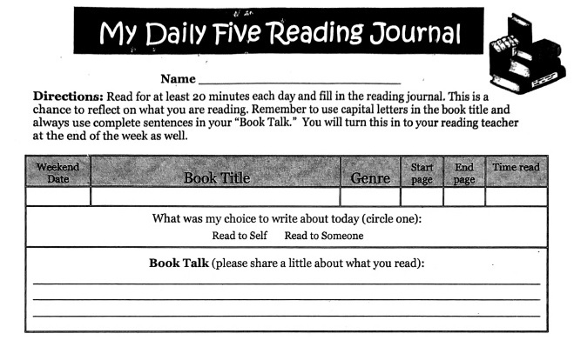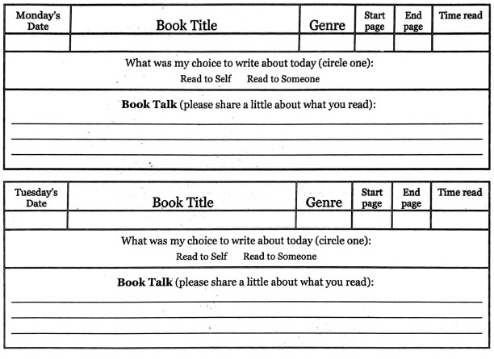 Teacher: Ms. Roberts

Teacher: Ms. Roberts

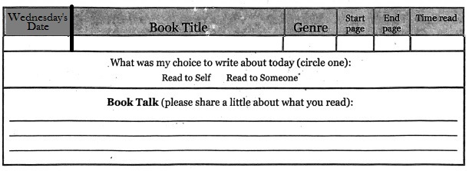

The Reading Journal is due at the end of the week in reading class. Parents need to sign the Reading Journals, and each day must be completed with two sentences written in order for them to be accepted as completed work.

Parent Signature: __________________________________ Date:_____

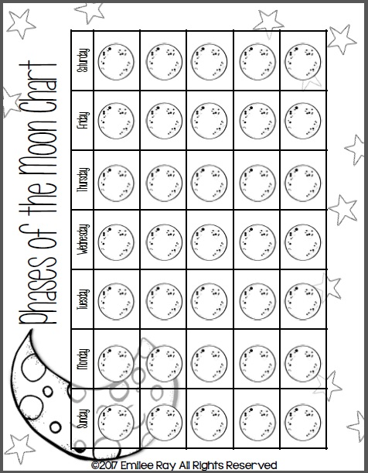

Mark down the observed shape of the moon every night in October. ***Due Nov. 2nd.***

***Parent Information:***

***E-mail****:* ***________________________________________________________***

***Cell Phone:_____________________________________________________***

***Home Phone:____________________________________________________***

***Address:________________________________________________________***

**Please fill this out if I have not contacted you on Class Dojo, e-mail, or by phone. I am hoping to maintain contact so I can tell you the great work that your students are doing, and things that we may need to work on together. I love working with Class Dojo because I can send you pictures of your student, and the work they are doing. I can also update you on class events, keep in touch during field trips, and send explanations of class assignments. So, if you have access to the internet, but do not have an e-mail account, you can set up an account for free on gmail. Just go to** [**www.gmail.com**](http://www.gmail.com)**, and you can set one up quickly and easily. Then I can also send you my newsletters through the email or my website so that the students don’t lose them on the way home, or misplace them. ☺**

|  |  |  |
| --- | --- | --- |
|  | **Oakridge Elementary School**  48119 First Street  Oakridge, Oregon 97463  Phone: (541) 782-3226  Fax: (541) 782-3122  E-mail: todonnell@ohswarriors.net | Tiffany O’Donnell  Principal |

October 5, 2017

I give permission for my child, , to watch

|  |  |  |
| --- | --- | --- |
| Movie Title | Date | Rating |
| ***The Borrowers*** | October 2017 | PG |
| ***Where the Red Fern Grows*** | December 2017 | G |
| ***Holes*** | February 2018 | PG |
| ***BFG*** | April 2018 | PG |
| ***Johnny Tremain*** | May 2018 | G |

**All movies are to be watched during lunch recess so that they will not disrupt class time. We are reading these books together in class, and being able to watch the movies is quite a bit of fun.**

**Parent/Guardian Signature Date**

**Plea for help in the classroom during Math:**

**Math is from 10-11:15 every day. I would love to do small groups to help the students with a bit more 1 on 1 help. If you are good with math (adding/subtracting/multiplying/dividing decimals and fractions) please consider volunteering and helping me in the classroom. The students would love to have some time to work with you and get some help with these difficult concepts. Remember, all that I teach is a tool to solve a problem. While knowing how to use the tools is good, if they get the answer correct in their own way, that is fine too.**

**Name: ______________________________ Date: __________**

**Home Phone: __________________ Cell: _________________**

**Yes! I would love to volunteer to lead a small group in Ms. Roberts’ Math class.**

**Monday Tuesday Wednesday Thursday**

**Signature: ___________________________________________________**