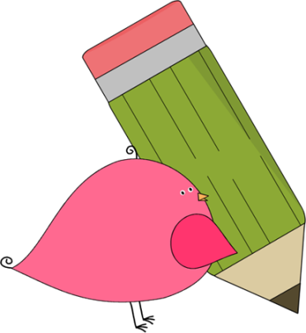

Ms. Roberts’ 5th Grade

Week of 9/25/17 – 9/28/17



From Ms. Roberts:

Greetings!

I hope your week has gone well! There have been a lot of animals showing up at the school. We saw tons of monarch butterflies today around the school. I wonder if that is supposed to mean anything regarding our weather. The class is going to be studying weather in science soon, and covering tools that are used for weather measuring and prediction. It might be fun if you could track the different weather at home.

The phases of the moon sheets are to be used starting Sunday. We are going to be tracking the moon phases for the entirety of October.

Wishing you all a fabulous weekend!

HOMEWORK:

* If you desire to work in the classroom as a volunteer, or join us on upcoming field trips, you will need to fill out a background check form.
* Please return the blue homework folders on Monday. Hardly any of the students are bringing them back.
* Students are allowed to bring water bottles to school. It works best to have refillable bottles that they can leave at school.
* Study Spelling and vocabulary words. Sheet Due Monday.
* 20 minutes of reading every day in a reading log. Due at the end of the week in reading class.
* My math kids are bringing home math sheets to practice almost every day. They are to only work on them for 30 minutes at most.



Important Dates and

Upcoming Events:

* Monday is wear “plaid” day
* Spelling Test Thursday, 10-5



Student Spotlight

Keep up the good work for perfect attendance! Our class has moved up to 4th place in the classroom for attendance! Way to Strive for Five!

C:\Documents and Settings\Jac\Local Settings\Temporary Internet Files\Content.IE5\OGYR678X\MC900391164[1].wmf

**Spelling List: Re-write the spelling words on the lines available.**

|  |  |  |
| --- | --- | --- |
| **Spelling Word** | **Rewrite #1** | **Rewrite #2** |
| 1. **vacation** |  |  |
| 1. **reach** |  |  |
| 1. **describe** |  |  |
| 1. **sustain** |  |  |
| 1. **sleep** |  |  |
| 1. **flight** |  |  |
| 1. **break** |  |  |
| 1. **seize** |  |  |
| 1. **sky** |  |  |
| 1. **weigh** |  |  |
| 1. **field** |  |  |
| 1. **pioneer** |  |  |
| 1. **airplane** |  |  |
| 1. **study** |  |  |
| 1. **clay** |  |  |
| **Vocabulary Words: May be used as extra credit spelling words.** | **Definition** | |
| 1. **Past Tense** |  | |
| 1. **Verb** |  | |
| 1. **Noun** |  | |

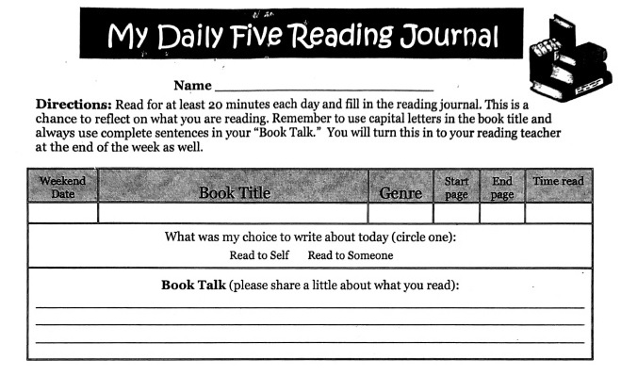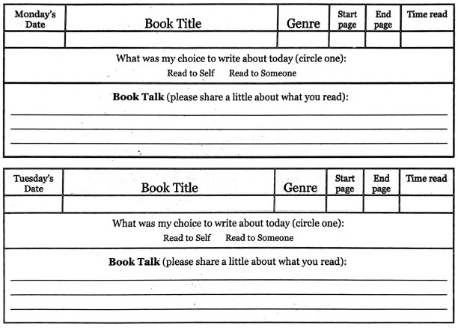 Teacher: Ms. Roberts

Teacher: Ms. Roberts

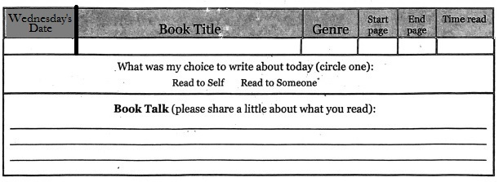

The Reading Journal is due at the end of the week in reading class. Parents need to sign the Reading Journals, and each day must be completed with two sentences written in order for them to be accepted as completed work.

Parent Signature: __________________________________ Date:_____

