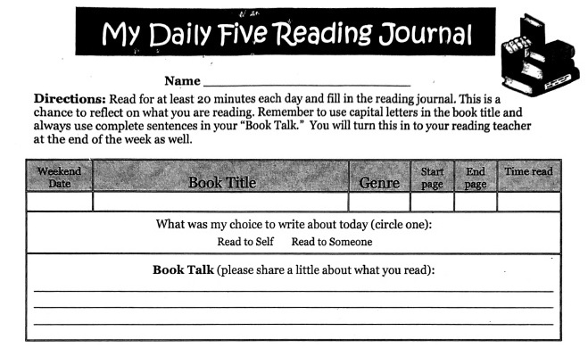
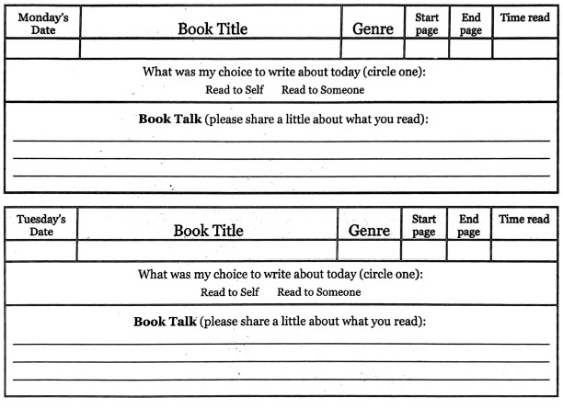
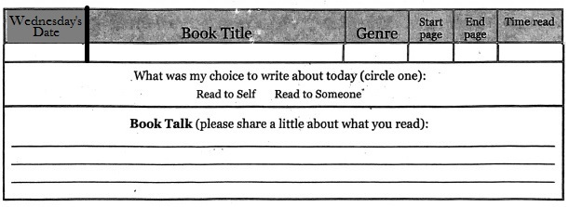

The Reading Journal is due at the end of the week in reading class. Parents need to sign the Reading Journals, and each day must be completed with two sentences written in order for them to be accepted as completed work.

Parent Signature: __________________________________ Date:_____

