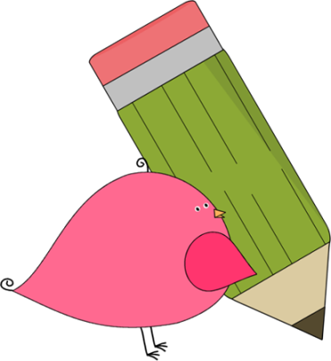

Ms. Roberts’ 5th Grade

Week of 9/5/17 – 9/8/17

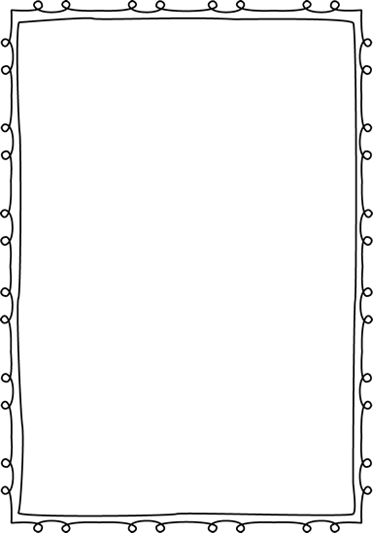

HOMEWORK:

* Registration forms are due. Please check the information, sign them, and return them.
* If you desire to work in the classroom as a volunteer, or join us on upcoming field trips, you will need to fill out a background check form.
* I will be sending home a blue folder with all information and homework that I wish to send you. Please return it with your child on the next day with all parent forms signed.
* Students are allowed to bring water bottles to school. It works best to have refillable bottles that they can leave at school.
* Study Spelling and vocabulary words.
* 20 minutes of reading every day in a reading log.

From Ms. Roberts:

Greetings everyone!

It was such a pleasure to meet all the kids this week! They have done an excellent job paying attention to instruction, and working in their homeroom binders.

So far, we have covered the phases of the moon, place values up to millions and down to thousandths, decimal conversions to money and fractions, and have compared and contrasted stories in a book that we completed this week. Some of the students have already earned points for the books they have read as well which is awesome.

Soon we should be receiving laptops for every student to use, we are just waiting for them to be assigned. Math and Reading classes begin next week, so the students will be experiencing what it is like to transition to a different class.

All in all it was a fantastic week, and I can’t wait to see them on Monday!



Important Dates and

Upcoming Events:

* Spelling Test Wednesday, 9-13
* No School Thursday and Friday of next week. (September 14th and 15th)



Student Spotlight

Great work class on making our attendance for week one fantastic! For the first week we had 3 perfect attendance days! Great job!

C:\Documents and Settings\Jac\Local Settings\Temporary Internet Files\Content.IE5\OGYR678X\MC900391164[1].wmf

**Spelling List: Re-write the spelling words on the lines available.**

|  |  |  |
| --- | --- | --- |
| **Spelling Word** | **Rewrite #1** | **Rewrite #2** |
| 1. **Perhaps** |  |  |
| 1. **Necklace** |  |  |
| 1. **Sweater** |  |  |
| 1. **Inch** |  |  |
| 1. **Happen** |  |  |
| 1. **Empty** |  |  |
| 1. **Invent** |  |  |
| 1. **Athlete** |  |  |
| 1. **Elephant** |  |  |
| 1. **Until** |  |  |
| 1. **Accident** |  |  |
| 1. **Spell** |  |  |
| 1. **City** |  |  |
| 1. **Adventure** |  |  |
| 1. **Important** |  |  |

**Name______________ Date____**

**Reading Homework**

**Summarize:** 1. Shorten the story 2. Include only important details

Read **20 minutes a day**. Your weekly total should be at least **80 minutes**. Turn in Thursday morning.

**Weekend:** _____ **min.** Book __________________________________________

Summary of what you read: ____________________________________________________________________________________________________________________________________________________________________________________

**Monday:** _____ **min.** Book ___________________________________________

Summary of what you read: ____________________________________________________________________________________________________________________________________________________________________________________

**Tuesday:** _____ **min.** Book ___________________________________________

Summary of what you read: ____________________________________________________________________________________________________________________________________________________________________________________

**Wednesday:** _____ **min.** Book ________________________________________

Summary of what you read: ____________________________________________________________________________________________________________________________________________________________________________________

Be honest on this record; reading improves your capabilities in every subject, increases your spelling knowledge, and is the best way to expand your vocabulary.

**Parent Signature:** _____________________ **Date:** _________