

Ms. Roberts’ 5th Grade

Week of 11/13/17 – 11/17/17



From Ms. Roberts:

PHEW!

Conferences are next week, and I am glad that I am almost prepared. The students have been working hard on their self-evaluations. They have chosen the work that they want to present to you, of which I am very pleased with their selections.

The students learned about cave art of indigenous peoples this week, creating their own rock paintings and short stories to describe what their rock art is about. I am excited to read the stories that they come up with.

Next week is the time for stuffing ourselves with goodies, and sharing our time with the people we care about. I am thankful for my class, thankful that I am a teacher and can do what I love, and thankful for you who supports the learning of your child at home. Thank you from the bottom of my heart for all that you do for your child and this classroom. The students succeed when we all work together, and I have to say that I have enjoyed how we have been communicating so well this year.

Have a Happy Thanksgiving!

P.S. Reading Journals done over Thanksgiving break are NOT required, but are extra credit. If turned in completed, the students will earn a prize.

HOMEWORK:

* If you desire to work in the classroom as a **volunteer**, or join us on upcoming field trips, you will need to fill out a background check form.
* Please return the **blue homework folders** every school day. If
* **Study Spelling and vocabulary** words. Sheet Due Monday.
* **20 minutes of reading** every day in a reading log. Due at the end of the week in reading class.
* My **math** kids are bringing home math sheets to practice almost every day. They are to only work on them for **30 minutes at most**.
* **At least 30 minutes** of outside activity every day. If it can be made a family endeavor, such as a walk, that would be a great way to encourage your child to stay active, and get some fresh air.
* Students need to turn in their signed permission slips to watch the class movies.





Important Dates and

Upcoming Events:

* Spelling Test Friday, 12-1
* Parent/Teacher Conferences 11-21 and 22
* YES! There IS school Friday 11-17! Strive for Five, and keep our attendance high this term. ☺

Student Spotlight

The students did a fabulous job on their first speech! I am so proud of how they put their time and effort into their buildings.

Bravo to Ace who gained the most interest of his audience because of his knowledge of the subject.

C:\Documents and Settings\Jac\Local Settings\Temporary Internet Files\Content.IE5\OGYR678X\MC900391164[1].wmf

**Spelling List: Re-write the spelling words on the lines available.**

|  |  |  |
| --- | --- | --- |
| **Spelling Word** | **Rewrite #1** | **Rewrite #2** |
| 1. **Aught** |  |  |
| 1. **Bought** |  |  |
| 1. **Caught** |  |  |
| 1. **Brought** |  |  |
| 1. **Daughter** |  |  |
| 1. **Cough** |  |  |
| 1. **Distraught** |  |  |
| 1. **Fought** |  |  |
| 1. **Fraught** |  |  |
| 1. **Ought** |  |  |
| 1. **Naught** |  |  |
| 1. **Sought** |  |  |
| 1. **Taught** |  |  |
| 1. **Thought** |  |  |
| 1. **Trough** |  |  |
| **Definition** | | |
| 1. **Adjective** |  | |
| 1. **Pronoun** |  | |
| 1. **Helping Verb** |  | |

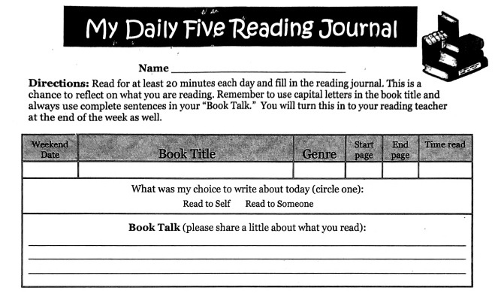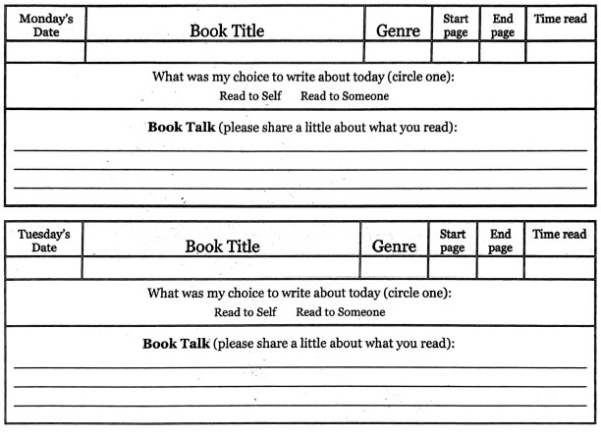 Teacher: Ms. Roberts

Teacher: Ms. Roberts

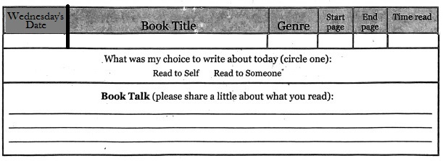

The Reading Journal is due at the end of the week in reading class. Parents need to sign the Reading Journals, and each day must be completed with two sentences written in order for them to be accepted as completed work.

Parent Signature: __________________________________ Date:_____