

Ms. Roberts’ 5th Grade

Week of 9/11/17 – 9/13/17



From Ms. Roberts:

Greetings everyone!

I have to laugh at myself sometimes. In reviewing my newsletter from last week I noticed that I made some mistakes.

1. At the top it said 6th grade and not 5th
2. I forgot to add that the students should bring water bottles to class. (This reduces how many times they need to leave the classroom for a drink.)
3. I didn’t get the blue folders out to the students in time. This was due to the newsletter not printing because of technical difficulties. (Please return those each day by the way.)
4. The newsletter was not stapled together. (There were three pages.)
5. I forgot to include which words are vocabulary words, so this weeks’ spelling test did not have a vocabulary quiz with it. The spelling list for next weeks’ test does have the vocabulary words and will be included on the test.

I apologize for my mistakes. I guess it proves that everyone makes them, even teachers.

HOMEWORK:

* Registration forms are due. Please check the information, sign them, and return them.
* If you desire to work in the classroom as a volunteer, or join us on upcoming field trips, you will need to fill out a background check form.
* I will be sending home a blue folder with all information and homework that I wish to send you. Please return it with your child on the next day with all parent forms signed.
* Students are allowed to bring water bottles to school. It works best to have refillable bottles that they can leave at school.
* Study Spelling and vocabulary words. Sheet Due Monday.
* 20 minutes of reading every day in a reading log. Due at the end of the week in reading class.



Important Dates and

Upcoming Events:

* Spelling Test Wednesday, 9-21
* No School Thursday and Friday of this week. (September 14th and 15th)
* Curriculum Night Tonight, Wednesday the 13th. 5-6 pm free dinner in cafeteria. 6-7 pm (3)20 minute rounds of visits with teachers.



Student Spotlight

Keep up the good work for perfect attendance! Our class was in the top 5 for attendance with a 99.5% attendance rate! Way to Strive for Five!

C:\Documents and Settings\Jac\Local Settings\Temporary Internet Files\Content.IE5\OGYR678X\MC900391164[1].wmf

**Spelling List: Re-write the spelling words on the lines available.**

|  |  |  |
| --- | --- | --- |
| **Spelling Word** | **Rewrite #1** | **Rewrite #2** |
| 1. **Possible** |  |  |
| 1. **Because** |  |  |
| 1. **Straw** |  |  |
| 1. **Broad** |  |  |
| 1. **Bought** |  |  |
| 1. **Swung** |  |  |
| 1. **Problem** |  |  |
| 1. **Taught** |  |  |
| 1. **Paw** |  |  |
| 1. **Sought** |  |  |
| 1. **Jungle** |  |  |
| 1. **Brought** |  |  |
| 1. **Shuttle** |  |  |
| 1. **Lobster** |  |  |
| 1. **Umbrella** |  |  |
| **Vocabulary Words: May be used as extra credit spelling words.** | **Definition** | |
| 1. **Nomad** |  | |
| 1. **Seminomadic** |  | |
| 1. **Elevation** |  | |

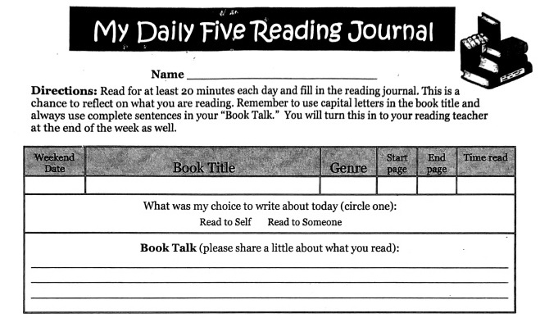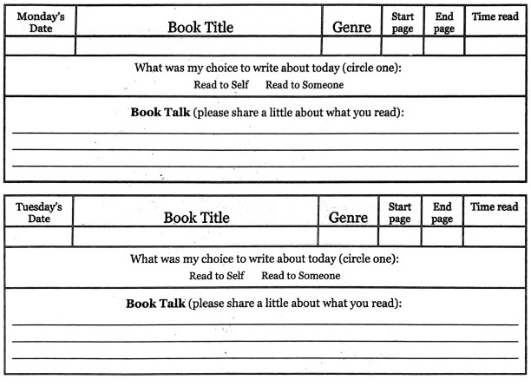 Teacher: Ms. Roberts

Teacher: Ms. Roberts

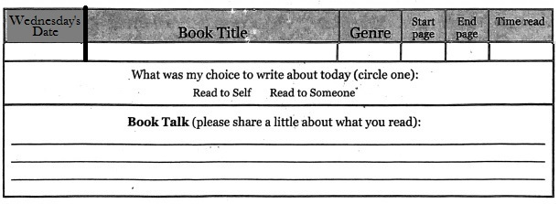

The Reading Journal is due at the end of the week in reading class. Parents need to sign the Reading Journals, and each day must be completed with two sentences written in order for them to be accepted as completed work.

Parent Signature: __________________________________ Date:_____