

Ms. Roberts’ 5th Grade

Week of 10/2/17 – 10/5/17



From Ms. Roberts:

It’s definitely getting colder!

The air conditioner is turned off, except for being used as a fan. In Science, the students are working well in class on their seasons projects, learning about how the position of the Earth effects the seasons. This goes great with understanding why the weather is changing at this time.

The students are going to have a fifth grade outdoor school/field trip to Trapper Creek Campground at Odell Lake on Wednesday the 11th. We are leaving at 8:40am and will return around 2:00pm. Please pack a sack lunch for your child and ensure they have good, closed toe walking shoes, and a coat/jacket. We need more chaperones, so please sign up! Chaperones, please arrive at 8:15 to receive your instructions and group assignments. Also, please get in the permission slips. If we do not get those in, the kids can not go on the field trip and will be staying at the school.

I am still trying to connect with everyone on Class Dojo, and do not have cell or emails for everyone yet. If you have a cell number or email please send it to me so that I may add you to my Class Dojo and be even better at communicating with you.

HOMEWORK:

* If you desire to work in the classroom as a volunteer, or join us on upcoming field trips, you will need to fill out a background check form.
* Please return the blue homework folders on Monday. Hardly any of the students are bringing them back.
* Students are allowed to bring water bottles to school. It works best to have refillable bottles that they can leave at school.
* Study Spelling and vocabulary words. Sheet Due Monday.
* 20 minutes of reading every day in a reading log. Due at the end of the week in reading class.
* My math kids are bringing home math sheets to practice almost every day. They are to only work on them for 30 minutes at most.



Important Dates and

Upcoming Events:

* Wednesday, October 11, field trip to Odell Lake. 8:40am to 2:00pm
* Spelling Test Thursday, 10-5



Student Spotlight

Keep up the good work for perfect attendance! Our class has retained 4th place in the classroom for attendance! Way to Strive for Five!

C:\Documents and Settings\Jac\Local Settings\Temporary Internet Files\Content.IE5\OGYR678X\MC900391164[1].wmf

**Spelling List: Re-write the spelling words on the lines available.**

|  |  |  |
| --- | --- | --- |
| **Spelling Word** | **Rewrite #1** | **Rewrite #2** |
| 1. **Banjo** |  |  |
| 1. **Broken** |  |  |
| 1. **General** |  |  |
| 1. **American** |  |  |
| 1. **Major** |  |  |
| 1. **Kitten** |  |  |
| 1. **Ginger** |  |  |
| 1. **Camp** |  |  |
| 1. **Object** |  |  |
| 1. **Market** |  |  |
| 1. **Legend** |  |  |
| 1. **Character** |  |  |
| 1. **Subject** |  |  |
| 1. **Monkey** |  |  |
| 1. **Electric** |  |  |
| **Vocabulary Words: May be used as extra credit spelling words.** | **Definition** | |
| 1. **Variant** |  | |
| 1. **Context** |  | |
| 1. **Synonym** |  | |

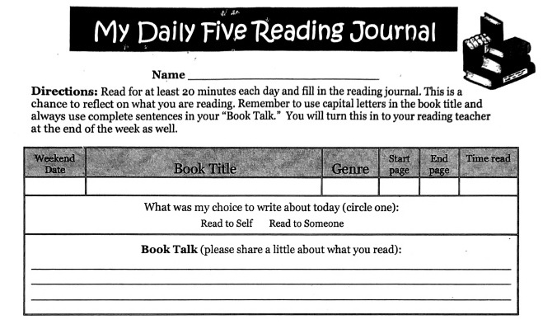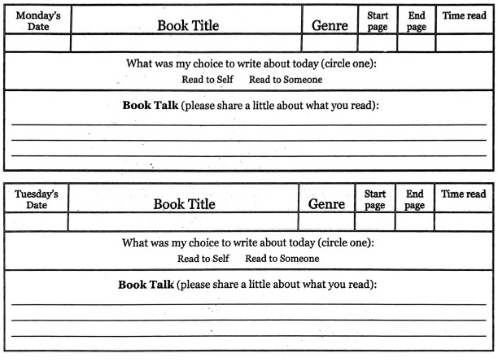 Teacher: Ms. Roberts

Teacher: Ms. Roberts

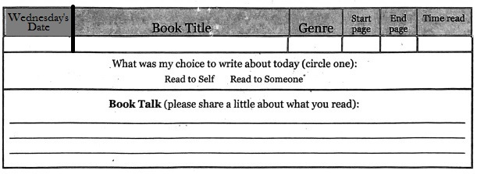

The Reading Journal is due at the end of the week in reading class. Parents need to sign the Reading Journals, and each day must be completed with two sentences written in order for them to be accepted as completed work.

Parent Signature: __________________________________ Date:_____

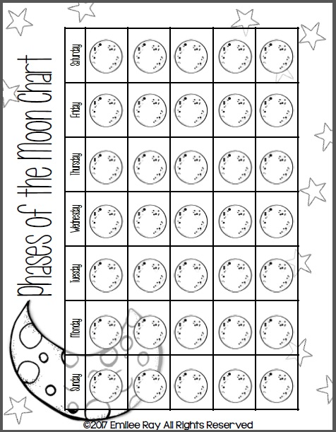

Mark down the observed shape of the moon every night in October. ***Due Nov. 2nd.***

***Parent Information:***

***E-mail****:* ***________________________________________________________***

***Cell Phone:_____________________________________________________***

***Home Phone:____________________________________________________***

***Address:________________________________________________________***

**Please fill this out if I have not contacted you on Class Dojo, e-mail, or by phone. I am hoping to maintain contact so I can tell you the great work that your students are doing, and things that we may need to work on together. I love working with Class Dojo because I can send you pictures of your student, and the work they are doing. I can also update you on class events, keep in touch during field trips, and send explanations of class assignments. So, if you have access to the internet, but do not have an e-mail account, you can set up an account for free on gmail. Just go to** [**www.gmail.com**](http://www.gmail.com)**, and you can set one up quickly and easily. Then I can also send you my newsletters through the email or my website so that the students don’t lose them on the way home, or misplace them. ☺**

|  |  |  |
| --- | --- | --- |
|  | **Oakridge Elementary School**  48119 First Street  Oakridge, Oregon 97463  Phone: (541) 782-3226  Fax: (541) 782-3122  E-mail: todonnell@ohswarriors.net | Tiffany O’Donnell  Principal |

October 5, 2017

I give permission for my child, , to watch

|  |  |  |
| --- | --- | --- |
| Movie Title | Date | Rating |
| ***The Borrowers*** | October 2017 | PG |
| ***Where the Red Fern Grows*** | December 2017 | G |
| ***Holes*** | February 2018 | PG |
| ***BFG*** | April 2018 | PG |
| ***Johnny Tremain*** | May 2018 | G |

**All movies are to be watched during lunch recess so that they will not disrupt class time. We are reading these books together in class, and being able to watch the movies is quite a bit of fun.**

**Parent/Guardian Signature Date**