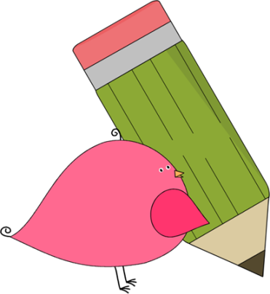

Ms. Roberts’ 5th Grade

Week of 9/18/17 – 9/21/17

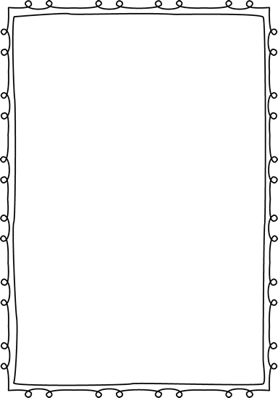

From Ms. Roberts:

Happy Fall Everyone!

That’s right! Tomorrow is the first day of Fall. I am very happy with the dedication the students have been demonstrating in class regarding their work. I have had some issues in class regarding mechanical pencils and pens though. There is an activity going around that some of the kids have learned on YouTube where they take the pens and mechanical pencils apart and rearrange the springs to create automatic shooters. This is a very inappropriate and dangerous use of their tools for learning, and I have informed them at this point that I never want to see them again. I have decided as a result that I do not want mechanical pencils or pens in the classroom anymore. This may be upsetting to some of the students as they really like those tools, but after three weeks of school with no change in actions I feel it is necessary.

HOMEWORK:

* Registration forms are due. Please check the information, sign them, and return them.
* If you desire to work in the classroom as a volunteer, or join us on upcoming field trips, you will need to fill out a background check form.
* I will be sending home a blue folder with all information and homework that I wish to send you. Please return it with your child on the next day with all parent forms signed.
* Students are allowed to bring water bottles to school. It works best to have refillable bottles that they can leave at school.
* Study Spelling and vocabulary words. Sheet Due Monday.
* 20 minutes of reading every day in a reading log. Due at the end of the week in reading class.



Important Dates and

Upcoming Events:

* Spelling Test Thursday, 9-28



Student Spotlight

Keep up the good work for perfect attendance! Our class has retained fifth place in the classroom for attendance! Way to Strive for Five!

C:\Documents and Settings\Jac\Local Settings\Temporary Internet Files\Content.IE5\OGYR678X\MC900391164[1].wmf

**Spelling List: Re-write the spelling words on the lines available.**

|  |  |  |
| --- | --- | --- |
| **Spelling Word** | **Rewrite #1** | **Rewrite #2** |
| 1. **Vacation** |  |  |
| 1. **Reach** |  |  |
| 1. **Describe** |  |  |
| 1. **Sustain** |  |  |
| 1. **Sleep** |  |  |
| 1. **Flight** |  |  |
| 1. **Break** |  |  |
| 1. **Seize** |  |  |
| 1. **Sky** |  |  |
| 1. **Weigh** |  |  |
| 1. **Field** |  |  |
| 1. **Pioneer** |  |  |
| 1. **Airplane** |  |  |
| 1. **Study** |  |  |
| 1. **Clay** |  |  |
| **Vocabulary Words: May be used as extra credit spelling words.** | **Definition** | |
| 1. **Past Tense** |  | |
| 1. **Verb** |  | |
| 1. **Noun** |  | |

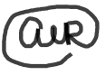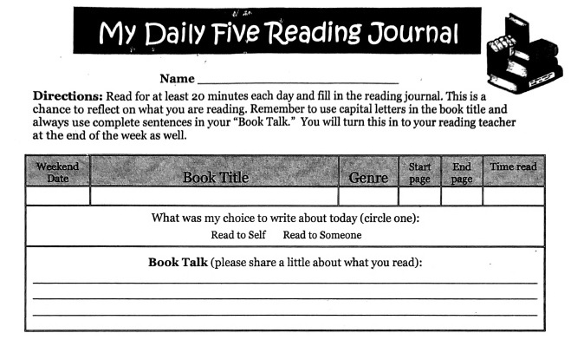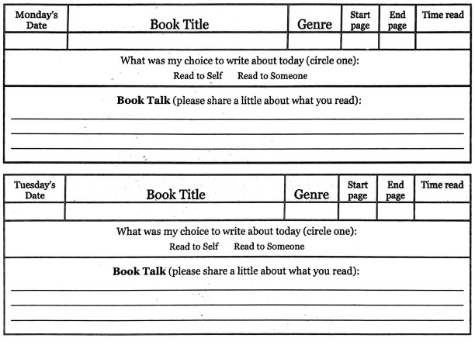 Teacher: Ms. Roberts

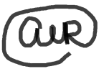Teacher: Ms. Roberts

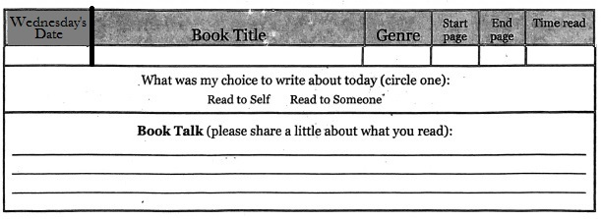

The Reading Journal is due at the end of the week in reading class. Parents need to sign the Reading Journals, and each day must be completed with two sentences written in order for them to be accepted as completed work.

Parent Signature: __________________________________ Date:_____