

Ms. Roberts’ 5th Grade

Week of 10/30/17 – 11/2/17



From Ms. Roberts:

I hope you had a very happy Halloween/Harvest Day!

The kids had a great time at our Fall Harvest Party on Tuesday! I did too! We had pumpkin bowling…until the pumpkin was squashed. We then relied on the tried and true game of “telephone”. We also had pumpkin bingo, snacks, and read “The Reasons for Seasons”. It was a fantastic hour of learning and fun, and I am so glad that we were able to do it! The kids were behaving excellent the entire time, and I couldn’t have been happier. Thank you to Mrs. Zylstra and Mrs. Vosika for your excellent work as volunteers. I am so thankful for you! Thank you as well to those who donated snacks for the occasion. It was great to have a variety available to us.

There was a science quiz on weather, weather instruments, and the beginnings of our moon studies. The kids are learning about the cycles that we have in nature, and how even the seasons and the animal’s reactions to them happen over, and over, and over again.

The first grading period is over! Give yourselves a pat on the back for getting through it! The students deserve pats on the back too. ☺

HOMEWORK:

* If you desire to work in the classroom as a **volunteer**, or join us on upcoming field trips, you will need to fill out a background check form.
* Please return the **blue homework folders** every school day. If
* **Study Spelling and vocabulary** words. Sheet Due Monday.
* **20 minutes of reading** every day in a reading log. Due at the end of the week in reading class.
* My **math** kids are bringing home math sheets to practice almost every day. They are to only work on them for **30 minutes at most**.
* **At least 30 minutes** of outside activity every day. If it can be made a family endeavor, such as a walk, that would be a great way to encourage your child to stay active, and get some fresh air.
* Students need to turn in their signed permission slips to watch the class movies.





Important Dates and

Upcoming Events:

* Picture Retakes Thursday, 11-2
* Spelling Test Thursday, 11-9
* Indian Dwellings Due 11-9

Student Spotlight

Congratulations to John, Efren, and Ayden, our students of the month!

C:\Documents and Settings\Jac\Local Settings\Temporary Internet Files\Content.IE5\OGYR678X\MC900391164[1].wmf

**Spelling List: Re-write the spelling words on the lines available.**

|  |  |  |
| --- | --- | --- |
| **Spelling Word** | **Rewrite #1** | **Rewrite #2** |
| 1. **Chalk** |  |  |
| 1. **August** |  |  |
| 1. **Crawl** |  |  |
| 1. **Foundation** |  |  |
| 1. **Annoy** |  |  |
| 1. **Cancel** |  |  |
| 1. **False** |  |  |
| 1. **Author** |  |  |
| 1. **Lawn** |  |  |
| 1. **Our** |  |  |
| 1. **Loyal** |  |  |
| 1. **Label** |  |  |
| 1. **Salt** |  |  |
| 1. **Autograph** |  |  |
| 1. **Outside** |  |  |
| **Definition** | | |
| 1. **Compound Words** |  | |
| 1. **Context** |  | |
| 1. **Unscramble** |  | |

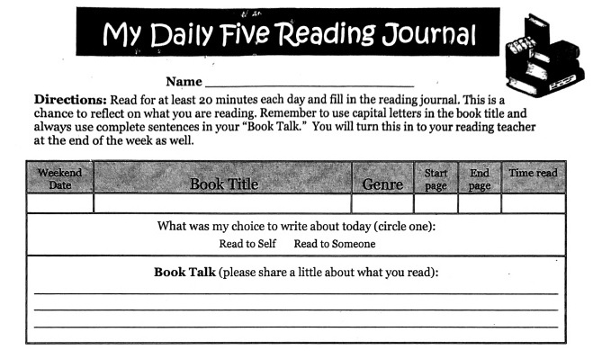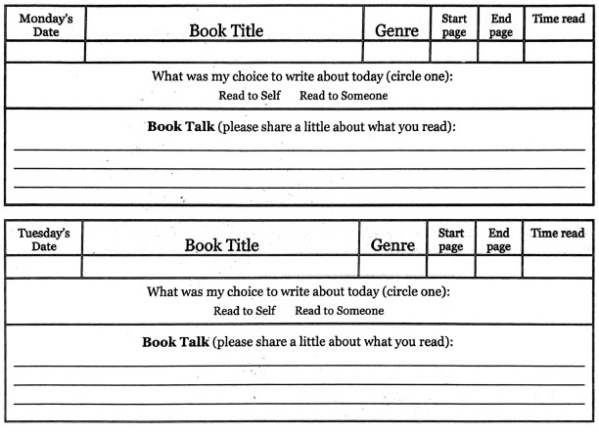 Teacher: Ms. Roberts

Teacher: Ms. Roberts

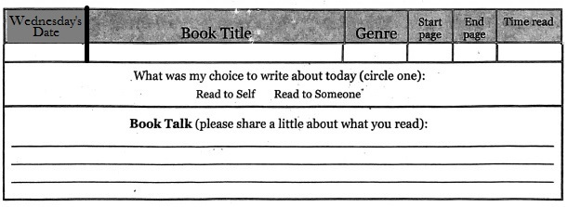

The Reading Journal is due at the end of the week in reading class. Parents need to sign the Reading Journals, and each day must be completed with two sentences written in order for them to be accepted as completed work.

Parent Signature: __________________________________ Date:_____

***Parent Information:***

*Thank you to those of you who have filled this out. If you have already turned yours in, you do not need to fill this out again.*

***E-mail****:* ***________________________________________________________***

***Cell Phone:_____________________________________________________***

***Home Phone:____________________________________________________***

***Address:________________________________________________________***

Please fill this out **if I have not** contacted you on Class Dojo, e-mail, or by phone. I am hoping to maintain contact so I can tell you the great work that your students are doing, and things that we may need to work on together. I love working with Class Dojo because I can send you pictures of your student, and the work they are doing. I can also update you on class events, keep in touch during field trips, and send explanations of class assignments. So, if you have access to the internet, but do not have an e-mail account, you can set up an account for free on gmail. Just go to [www.gmail.com](http://www.gmail.com), and you can set one up quickly and easily. Then I can also send you my newsletters through the email or my website so that the students don’t lose them on the way home, or misplace them. ☺

|  |  |  |
| --- | --- | --- |
|  | **Oakridge Elementary School**  48119 First Street  Oakridge, Oregon 97463  Phone: (541) 782-3226  Fax: (541) 782-3122  E-mail: todonnell@ohswarriors.net | Tiffany O’Donnell  Principal |

October 5, 2017

I give permission for my child, , to watch

|  |  |  |
| --- | --- | --- |
| Movie Title | Date | Rating |
| ***The Borrowers*** | October 2017 | PG |
| ***Where the Red Fern Grows*** | December 2017 | G |
| ***Holes*** | February 2018 | PG |
| ***BFG*** | April 2018 | PG |
| ***Johnny Tremain*** | May 2018 | G |

**All movies are to be watched during lunch recess so that they will not disrupt class time. We are reading these books together in class, and being able to watch the movies is quite a bit of fun.**

**Parent/Guardian Signature Date**

**Plea for help in the classroom during Math:**

**Math is from 10-11:15 every day. I would love to do small groups to help the students with a bit more 1 on 1 help. If you are good with math (adding/subtracting/multiplying/dividing decimals and fractions) please consider volunteering and helping me in the classroom. The students would love to have some time to work with you and get some help with these difficult concepts. Remember, all that I teach is a tool to solve a problem. While knowing how to use the tools is good, if they get the answer correct in their own way, that is fine too.**

**Name: ______________________________ Date: __________**

**Home Phone: __________________ Cell: _________________**

**Yes! I would love to volunteer to lead a small group in Ms. Roberts’ Math class.**

**Monday Tuesday Wednesday Thursday**

**Signature: ___________________________________________________**